CS 255 System Design Document Template

UML Diagrams

UML Use Case Diagram

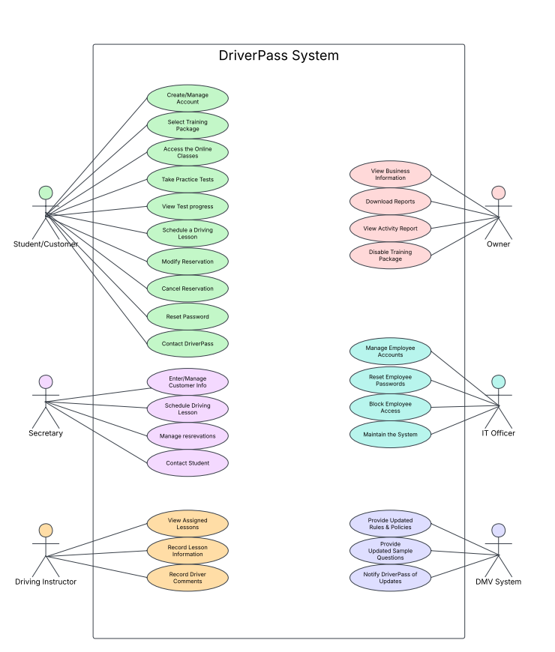

UML Activity Diagrams
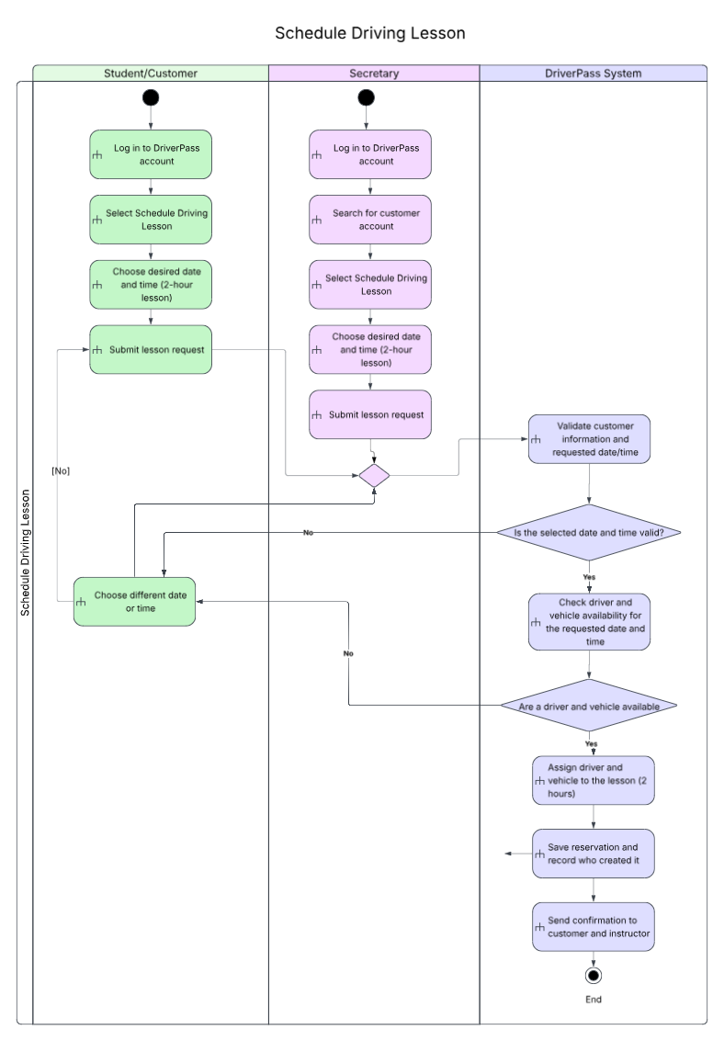

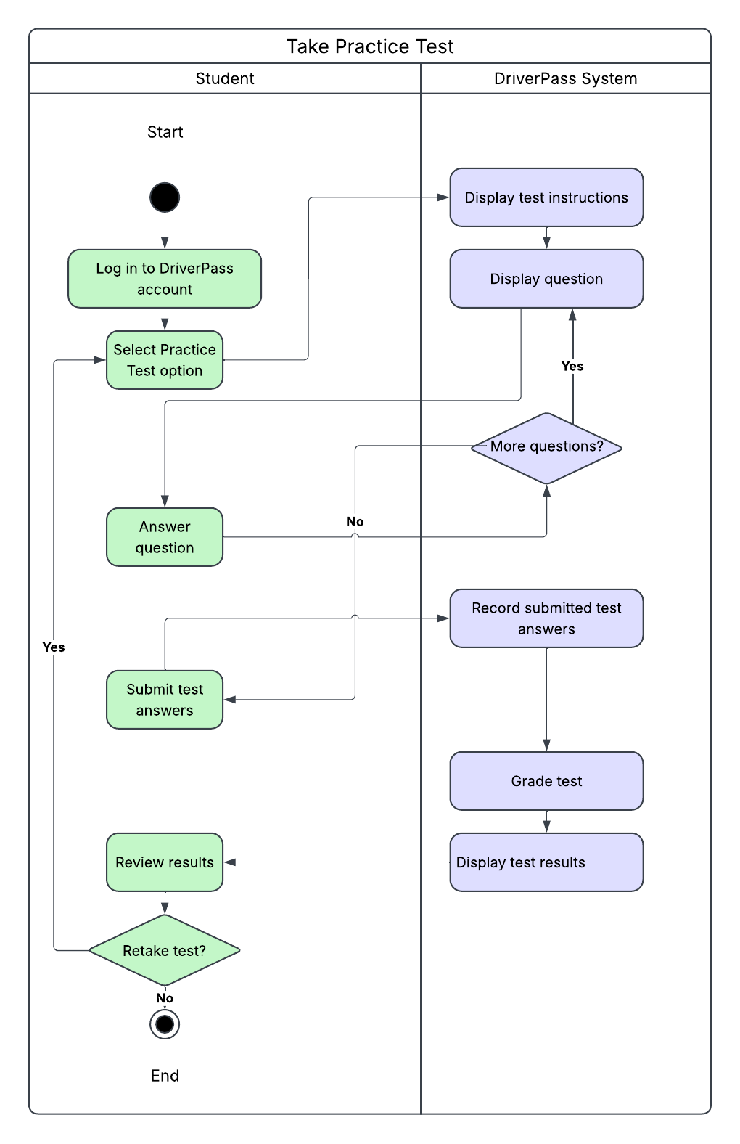

UML Sequence Diagram
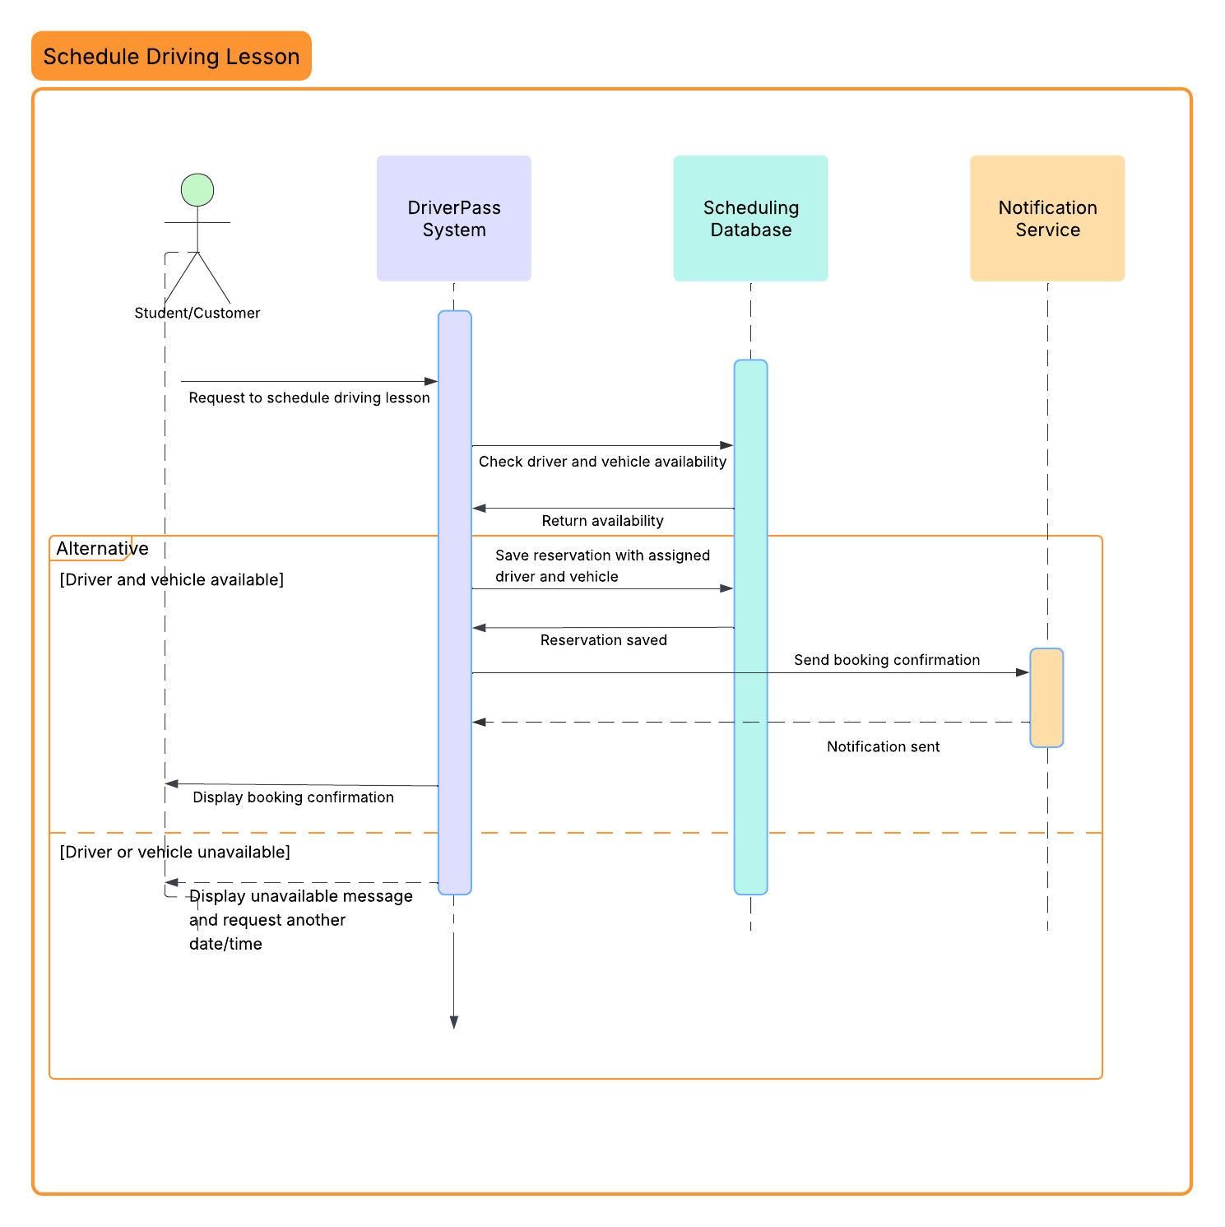

UML Class Diagrams
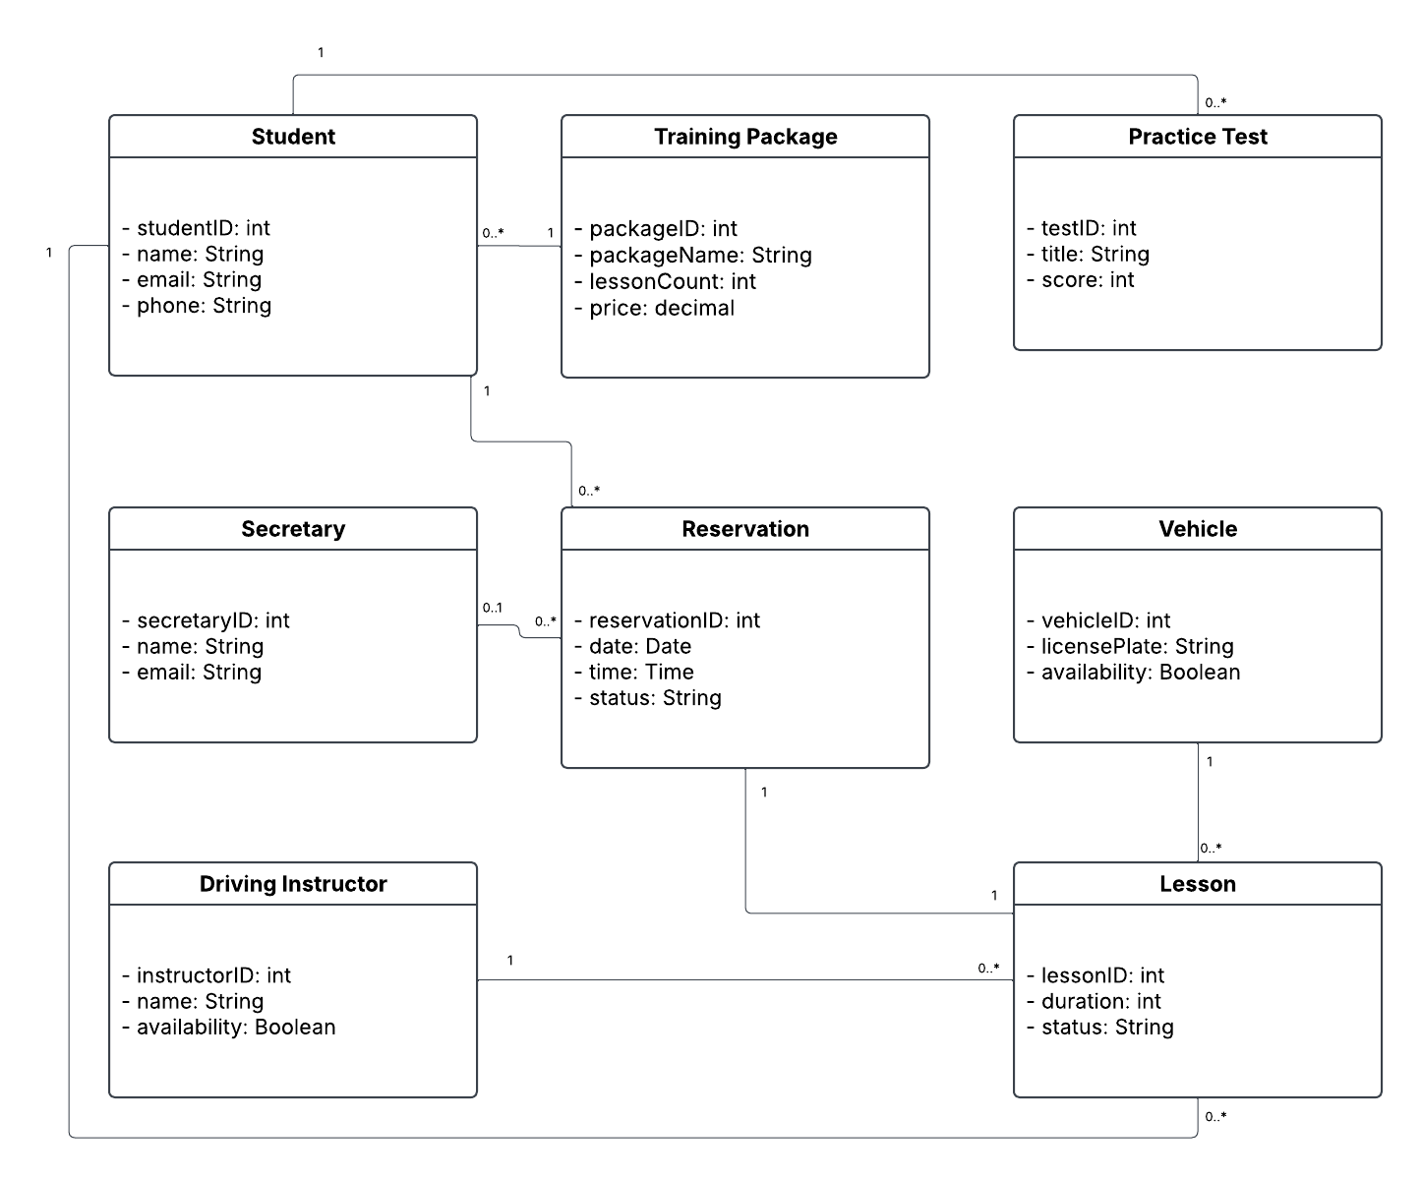

Technical Requirements
Hardware
DriverPass will need computers or laptops for the owner, the secretary, and the IT officer to manage customer accounts, the reservations, and the reports. Driving instructors will need tablets or smartphones so that they can check their schedules and record lesson information while they're away from the office. Students can use their own computers, tablets, or smartphones to access the system. Since the application will be hosted in the cloud, DriverPass won't need to purchase or maintain the physical servers at its office.

Software
DriverPass will use a web-based application that works with current versions of Chrome, Edge, Firefox, and Safari, and it’ll also need to support Windows, macOS, Linux, and mobile devices so that users aren't limited to one operating system. Every type of user will have different permissions based on their role. A managed SQL database will store the customer information, training packages, practice tests, and the lesson reservations. It’ll also keep track of instructor assignments, the vehicle availability, and changes that are made to reservations. The system will need secure login features, password resets, and account lockouts that will help to prevent unauthorized access. A notification service will send confirmations when lessons are scheduled.

Tools
The development team will need a code editor or integrated development environment (IDE) to build and maintain the application. Git & GitHub can help developers keep track of changes to the code and work together without overwriting each other's work. Lucidchart can be used to maintain the UML diagrams and to make updates when the system changes. The team will also need testing tools to make sure the scheduling process, practice tests, and other features work correctly. They'll need to check that the application works across different browsers and meets its performance and security requirements. Database management tools will help the IT officer monitor stored information and to troubleshoot any problems.

Infrastructure
DriverPass will have to have a reliable internet connection and cloud hosting so students and employees can access the system without being at the office. The cloud environment will include an application server and a managed SQL database, along with secure HTTPS connections using TLS encryption. Automated backups will help to protect the information in case something goes wrong. Role-based permissions and multifactor authentication for administrators will help to keep customer information secure, and audit logs will record changes to accounts and reservations. The system should load pages in less than three seconds and should remain available for scheduling lessons, taking practice tests, and managing accounts. DriverPass will also need a way to receive DMV information through external connections when that information is available. Since the system depends on an internet connection and cloud services, users won't be able to make updates while they’re offline.

